HW 5

AEEM 7010

XIN LI



The above stochastic parameter combination is the setup that I used to find all 5 roots of given function. Compare to the given example MatLab code, I added “episode”, which allows the algorithm to respectively searching in the same searching space. This is added for solving the randomness of the mutation, so we will not miss the opportunity to find particular root in particular searching space. The same purpose can be solved by increase the number of chromosomes, which expand the coverage over the search space. I also added “filter_thres” for determining duplicated solutions and reserving the better one among them.

After trying several different parameter combinations, I found out that “M” does not need to too large, as long as it is greater than the # of possible solutions, so we can save some computation power for other sections of the codes. “N” is strictly fixed as the # of variables. “MaxGen” is a tricky part, which is needed to be set to a proper value. A large “MaxGen” will waste too much computation power, and a small “MaxGen” will not be enough for us to reach certain precision. To solve this problem, I added a “converage check” function to terminate the generation if the fitness is showing a sign of convering. For “pc”, I used 0.75 so that child can have higher chance to replace parent, so that the generation can progress faster. I use relatively low “pm = 0.1” to increase the stability of generation progress and low “er = 0.1” to keep the diversity of my population. Then, the “fitness_thres” is used for determining which chromosome should be accepted or rejected.



**M = 2 vs M = 25**

M holds the candidate solutions, the larger M is, the more candidates we will have in pool. The benefits of having small M will increase the computation speed, however, if you have a bad mutation or get a bad child from crossover, you have lower chance to get rid of it. The left figure shows that the fitness is stucked at 2500 with 2 bad candidates and the children of these 2 candidates will repeat this bad generation. The right figure shows the benefits of having a larger candidate pool, so that even we have a bad mutation or crossover, we can quickly eliminate them and converage to optimal solution.

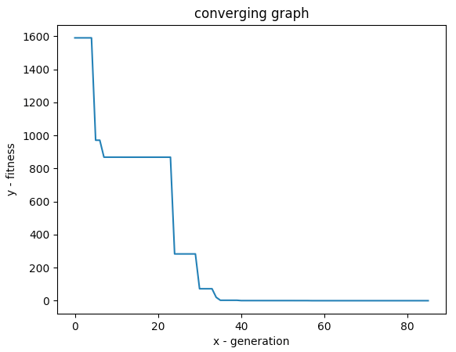

Above plot illustrate the importance of setting a proper value for “MaxGen”. As the plot shows, we have several converging points, such as fitness = 800, fitness = 250 and fitness = 0, and we will get a wrong solution if our “MaxGen” is too small.



**pc = 0.01 vs pc = 0.7**

Having a small probability for “pc” will lower the chance of replacing parent by child, which mean we will keep exploring the surrounding searching space without make much progress to our final solution. The above plots show that having a large pc will help us to converge earlier.



**pm = 0.99 vs pc = 0.01**

Although both settings help our algorithm reach the optimal threshold “0” at the early stage, high “pm” is not showing the sign of converging until the very end. If we are using converging as a signal to stop our iteration once we reach the optimal threshold, having a proper “pm” can dramatically save our computation power.



**er = 0.9 vs er = 0.1**

As we can see, the “er” does not affect the convergence too much. However, if we have multiple solution to find, we want to set a reasonable value for “er”, so it can select elite solution candidates, as well as keep our population stay diversative, so that other potential candidates can have a chance to compete with the elites.

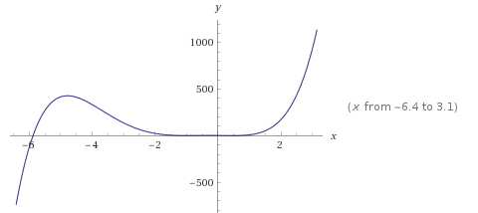 

From this homework assignment, I learned that GA has limitations. Above figure is the plot of given target function, and it is clear to see that the root approximately at point (0, -6) have a huge gradient compare to other roots within interval (-2, 1). Thus, imaging the roots that we want to finds are in two races, one is very smart (flat gradient, very easy to converge to 0), and another one is kind of dumb (sharp gradient, very hard to converge to 0). Running GA algorithm on a single domain and let these 2 races compete with each other will be a slaughter to the dumb race, since it will never have the chance to produce its next generation.

In order to solve this issue, I implemented a “protection_zone” method, a.k.a. segmentation method to isolate these 2 races, so that the “dumb” race will have a chance to produce its generation without competing with other “smart” races. As the result shows, the “dumb” race does converge to “0”, even it is less competitive compare to the “smart” races. Another implementation I can do for this instead of using segmentation is to adding diversity protection to the population. This ensures the population is always diverse, thus a small percentage of bad race will always remain in the population and hopefully to produce some good future generations.